 Semester One Examination 2009

Question/Answer Booklet

YEAR 12 CHEMISTRY

Name: _________________________

Time allowed for this paper

Reading time before commencing work: Ten minutes
Working time for paper: Two and a half hours

Materials required/recommended for this paper

To be provided by the supervisor
This Question/Answer Booklet

Separate Multiple Choice Answer Sheet
Chemistry Data Sheet (inside front cover of this Question/Answer Booklet)

To be provided by the candidate
Standard items: Pens pencils, eraser or correction fluid, ruler
Special items: A 2B, B or HB pencil for the separate Multiple Choice Answer Sheet and calculators satisfying the conditions set by the Curriculum Council for this subject.

Important note to candidates
No other items may be taken into the examination room. It is your responsibility to ensure that you do not have any unauthorised notes or other items of a non-personal nature in the examination room. If you have any unauthorised material with you, hand it to the supervisor before reading any further.
Structure of this paper
Part | Number of questions available | Number of questions to be attempted | Suggested working time | Marks available
- Multiple choice | 20 | All | 35min | 40 (25%)
- Short answers | 11 | All | 50min | 60 (37.5%)
- Calculations | 6 | All | 45min | 50 (31%)
- Extended answers | 1 | All | 20min | 10 (6.5%)
Total marks 160 (100%)

Instructions to candidates

- Answer the questions according to the following instructions:
Part 1 Answer all questions, using a 2B, B or HB pencil, on the separate Multiple Choice Answer Sheet. Do not use a ball point or ink pen.
If you consider that two or more of the alternative responses are correct, choose the one you think is best. If you think you know an answer, mark it even if you are not certain you are correct. Marks will not be deducted for incorrect answers.
Parts 2 and 3 Write your answers in the spaces provided in this Question/Answer Booklet. A blue or black ball point pen or ink pen should be used. Part 4 is to be answered on lined paper provided.
Questions containing specific instructions to show working should be answered with a complete logical, clear sequence of reasoning showing how the final answer was arrived at; correct answers which do not show working will not be awarded full marks.

- Chemical equations
For full marks, chemical equations should refer only to those species consumed in the reaction and the new species produced. These species may be ions, molecules or solids.
Teacher use only:
 | Mark | Out of
Part One
Part Two
Part Three
Part Four
Total
PART 1 (40 marks)
Answer ALL questions on the separate multiple choice answer sheet provided. Each question in this part is worth 2 marks.
_____________________________________________________________________

- Which one of the following atoms in its ground state has the greatest number of valence electrons?

- Al
- P
- S
- Si

- Two atoms, X and Y, have valence shell electron configurations of s²p⁴ and s². Which of the following would be the expected nature of a compound formed between X and Y?

- covalent network
- covalent molecular
- ionic
- molecular gas

3. Which one of the following chemicals is most suitable for use as a primary standard in an acid-base titration?

a) concentrated NH₃ solution
b) anhydrous Na₂CO₃
c) NaOH
d) hydrated Na₂CO₃

4. Consider the three weak acids, tellurous acid, H₂TeO₃, hydrazoic acid, HN₃, and nitrous acid, HNO₂. The conjugate bases of these acids would be

a) TeO₃²⁻, NH₄⁺ and HNO₂⁺
b) HTeO₃⁻, N₃⁻ and NO₂⁻
c) HTeO₃⁻, HN₂⁻ and NO₂⁻
d) TeO₃²⁻, NH₂⁻ and NO₃⁻

5. Which one of the following equilibria in aqueous solution would not be affected by diluting the solution with water?

a) [Co(H₂O)₆]²⁺(aq) + 4Cl⁻(aq) ↔ [CoCl₄]²⁻(aq) + 6H₂O(l)
b) Cr₂O₇²⁻(aq) + 2OH⁻(aq) ↔ 2CrO₄²⁻(aq) + H₂O(l)
c) Br₂(aq) + 2OH⁻(aq) ↔ OBr⁻(aq) + Br⁻(aq) + H₂O(l)
d) HPO₄²⁻(aq) + SO₄²⁻(aq) ↔ PO₄³⁻(aq) + HSO₄⁻(aq)
Refer to the following table listing some properties of four different substances for questions 6 and 7.

Substance | m.p | b.p | Other properties
A | 2700ºC | Sublimes | Dull, hard, non-conductor of electricity
B | -68 ºC | 57ºC | Oily liquid, non-conductor of electricity
C | -114ºC | -85ºC | Soluble in H₂O, solution conducts
D | 2800ºC | 3600ºC | Molten state conducts electricity

6. The substance which is most likely to be an ionic compound is

a) A
b) B
c) C
d) D

7. The substance which is most likely to be HCl is

a) A
b) B
c) C
d) D

8. The first ionisation energy of phosphorus is greater than that of aluminium. The best explanation of this is

a) the nucleus of a phosphorus atom has more protons than the nucleus of an aluminium atom and hence the valence electrons of phosphorus are more strongly held to the nucleus than those of aluminium.
b) ionisation energy increases across a period in the Periodic Table and phosphorus is further across Period 3 than aluminium.
c) the number of valence electrons in phosphorus is closer to a stable full shell than in aluminium and hence it is more difficult to lose an electron from phosphorus than aluminium.
d) metals have higher ionisation energies than non metals and phosphorus is a non metal.

9. Which list consists of elements that have the most similar chemical properties?

a) Mg, Al and Si
b) K, Al and Ni
c) Mg, Ca and Ba
d) K, Ca and Ga

10. A titration was conducted by adding NaOH from a Teflon-coated burette to an acid in a conical flask. The pH in the flask was recorded during the titration and Curve B was produced.
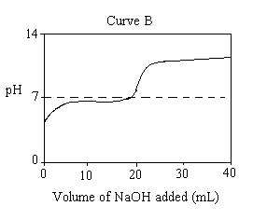
The table shows appropriate indicators used to identify the equivalence point in titrations.

Indicator | Acidic colour | Range of colour change | Basic colour
Methyl orange | Red | 3.1 – 4.4 | Yellow
Methyl red | Red | 4.4 – 6.2 | Yellow
Bromothymol blue | Yellow | 6.0 – 7.6 | Blue
Cresolphthalein | Colourless | 8.1 – 9.7 | Red
Alizarin yellow | Yellow | 10.1 – 12.0 | Red

What is the appropriate indicator for Curve B using the table?

a) Methyl orange
b) Methyl red
c) Cresolphthalein
d) Alizarin yellow

11. Deuterium (symbol D) is an isotope of hydrogen. Water made from deuterium has the formula D₂O and has similar properties to normal water. D₂O ionises according to the equilibrium

D₂O ↔ D⁺ + OD⁻
K = [D⁺] [OD⁻] = 1.82 x 10⁻¹⁶ at 25ºC

In a neutral solution of pure D₂O at 25ºC the concentration of D⁺, in mole per litre, is

a) 1.00 x 10⁻⁷
b) 1.35 x 10⁻⁸
c) 0.91 x 10⁻¹⁶
d) 1.82 x 10⁻¹⁶
12. A student adds solid KCl to water in a flask. The flask is sealed with a stopper and thoroughly shaken until no more solid KCl dissolves. Some solid KCl is still visible in the flask. The solution in the flask is

a) saturated and is at equilibrium with the solid KCl.
b) saturated and is not at equilibrium with the solid KCl.
c) unsaturated and is at equilibrium with the solid KCl.
d) unsaturated and is not at equilibrium with the solid KC.l

13. Given the potential energy diagram for a chemical reaction:

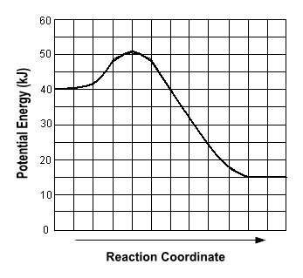

Which statement correctly describes the energy changes that occur in the forward reaction?

a) The activation energy is 10 kJ and the reaction is endothermic.
b) The activation energy is 10 kJ and the reaction is exothermic.
c) The activation energy is 50 kJ and the reaction is endothermic.
d) The activation energy is 50 kJ and the reaction is exothermic.

14. Which one of the following pairs of reactants will give a neutral solution when one mole of the first is mixed with one mole of the second?

a) HCl(aq) + Pb(NO₃)₂(aq)
b) H₂SO₄(aq) + NaOH(aq)
c) H₂SO₄(aq) + K₂O(s)
d) CH₃COOH(aq) + NaOH(aq)

15. Which symbol represents a particle that has the same total number of electrons as S²⁻?

a) O²⁻
b) Se²⁻
c) Si
d) Ar

16. Which one of the following reactions has the largest initial rate of reaction?
100 g of powdered calcium carbonate is mixed with

a) 10.0 mL of 1.00 mol L⁻¹ hydrochloric acid.
b) 80.0 mL of 1.00 mol L⁻¹ hydrochloric acid.
c) 40.0 mL of 2.00 mol L⁻¹ hydrochloric acid.
d) 5.0 mL of 4.00 mol L⁻¹ hydrochloric acid.

17. Which one of the following substances, when dissolved in water, gives a solution with the lowest pH?

a) Li₂O
b) Na₂O₂
c) H₂SO₄
d) HI

18. Given the reaction system in a closed container at equilibrium and at a temperature of 298 K:

N₂O₄(g) ↔ 2NO₂(g)

The measurable quantities of the gases at equilibrium must be

a) decreasing.
b) equal.
c) increasing.
d) constant.

19. Which statement best describes the equivalence point in a titration between a strong acid and a strong base?

a) The point at which the first sign of a colour change occurs.
b) The point at which equal moles of acid and base have been added together.
c) The point at which equal moles of H⁺ ions and OH⁻ ions have been added together.
d) The point at which the rate of the forward reaction equals the rate of the reverse reaction.

20. When iodine is dissolved in a solution of potassium iodide, an equilibrium is set up:

I⁻(aq) + I₂(aq) ↔ I₃⁻(aq)

Sodium thiosulfate (Na₂S₂O₃) reacts with iodine:

2S₂O₃²⁻(aq) + I₂(aq) → S₄O₆²⁻(aq) + 2I⁻(aq)

Which of the following changes would result when a solution of sodium thiosulfate is run from a burette into a solution of iodine in aqueous potassium iodide?

a) The concentration of I₃⁻ would decrease.
b) The concentration of I⁻ would increase.
c) The concentration of I₂ would increase.
d) The concentration of I⁻ and I₂ would remain constant.
PART 2 (60 marks)

Answer ALL questions in Part 2 in the spaces provided below.
__________________________________________________________________________________

1. Write equations for any reactions that occur in the following procedures. If no reaction occurs write “no reaction”.
In each case describe in full what you would observe, including any
- Colours
- Odours
- Precipitates (give the colour)
- Gases evolved (give the colour or describe as colourless)
If no change is observed, you should state this.

a) Solid sodium carbonate is added to a dilute solution of acetic (ethanoic) acid.

Equation _________________________________________________________

Observation _________________________________________________________

_______________________________________________________________
(3 marks)

b) An excess of hot sodium hydroxide solution is added to a piece of zinc.

Equation _________________________________________________________

Observation _________________________________________________________

_______________________________________________________________
(3 marks)

c) Solutions of cobalt chloride and sodium carbonate are mixed.

Equation _________________________________________________________

Observation _________________________________________________________

_______________________________________________________________
(3 marks)

d) Dilute sulfuric acid is added to some copper.

Equation _________________________________________________________

Observation _________________________________________________________

_______________________________________________________________
(3 marks)
2. Draw electron dot diagrams to represent the following substances.

OCl⁻ | BF₃
CS₂ | NH₄NO₂

(4 marks)
3. Write down the electron configuration (using s, p, d notation) for the following species
a) nitride ion _______________________________________

b) potassium atom _______________________________________
(2 marks)

4. A crystal of iodine, heated gently in a test-tube, gave off a purple vapour. A crystal of sodium iodide, heated to the same temperature remained unchanged.

a) Explain the above observations in terms of structure and bonding.

_______________________________________________________________

_______________________________________________________________

_______________________________________________________________

_______________________________________________________________

_______________________________________________________________
(3 marks)
b) Give the formula for the species responsible for the purple colour.

_____________________________________ (1 mark)
5. Pure water undergoes self-ionisation according to the following equilibrium:

2H₂O(l) ↔ H₃O⁺(aq) + OH⁻(aq)

The equilibrium constant for the ionisation of water (K_{w}) is 1.0 x 10⁻¹⁴ at 25ºC

The equilibrium constant expression for this reaction is

K = [H₃O⁺][OH⁻]

As the temperature is decreased the value of K_{w} decreases.

Is pure water acidic, basic or neutral at 10ºC? Explain your answer.

_______________________________________________________________

_______________________________________________________________

_______________________________________________________________
(2 marks)

6. Consider the 0.1 mol L⁻¹ solutions of:

Sodium hydroxide
Ammonium chloride
Sulfuric acid
Ethanoic(acetic) acid

a) Which solution would have the lowest electrical conductivity? Explain your answer.

_______________________________________________________________

_______________________________________________________________

_______________________________________________________________
(3 marks)
b) Which solution would have the highest pH? Explain your answer.

_______________________________________________________________

_______________________________________________________________

_______________________________________________________________
(2 marks)
c) Which solution would have the highest total concentration of ions?

_______________________________________________________________

(1 mark)

7. Consider the following chemical substances.

PCl₃, SiO₂, SiBr₄, F₂, CS₂, BeH₂, NH₄I, HCOOH

List all the non-polar molecules

List the molecules which would have hydrogen bonds between them

List the pyramid-shaped
molecules
(6 marks)

8. Write equilibrium constants for the following chemical equilibria:

a) TiO₂(s) + 2 Cl₂(g) + 2 C(s) ↔ TiCl₄(g) + 2 CO(g)

b) [Fe(H₂O)₆]³⁺(aq) + 6 SCN⁻(aq) ↔ [Fe(CN)₆]³⁻(aq) + 6H₂O(l)

a)
b)

(2 marks)

9. Calcium carbonate decomposes when heated

Energy + CaCO_{3(s)} ↔ CaO_{(s)} + CO_{2(g)}

If the mixture is present in a closed container equilibrium will be established.

Predict the effect of the following changes on the concentration of carbon dioxide at equilibrium and explain your predictions.

Change  Imposed | Effect on conc of CO_{2(g)} | Explanation
The pressure inside the container is increased by reducing the volume of the container
Helium gas is added
A small quantity of CaCO_{3(s)} is added
(9 marks)
10. Describe briefly a chemical test and observations by which you could distinguish between the following pairs of chemical substances. Equations are not necessary.

Substances | Test | Observations
Ba(NO₃)_{2(aq)}
and
Pb(NO₃)_{2(aq)}
Silver chloride solid
and
Silver carbonate solid

(4 marks)

11. Part of the Contact process for the manufacture of sulfuric acid involves the conversion of sulfur dioxide to sulfur trioxide as shown by the following equation
2SO₂(g) + O₂(g) ↔ 2SO₃(g) ∆H= -192kJmol⁻¹

In a study of this process, a container was filled with an equilibrium mixture of sulfur dioxide, sulfur trioxide and oxygen in the presence of a catalyst. The container was initially at 450ºC and was very well insulated.

An experiment was conducted on the container and the concentrations during the experiment are shown on the graph below:
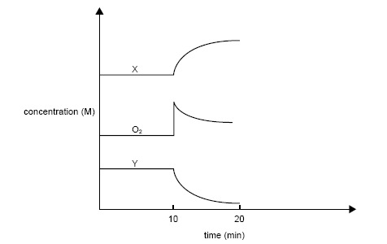
a) What change was imposed on the system at the 10 minute point? (1 mark)

__________________________________________________________________

b) Which components of the equilibrium mixture are represented by the lines labelled X and Y?

X _________________ Y _______________ (2 marks)

c) Give explanations for the changes in concentration that occur in X, Y and O₂ between 10 and 20 minutes

___________________________________________________________________

___________________________________________________________________

___________________________________________________________________

___________________________________________________________________

___________________________________________________________________

___________________________________________________________________
(3 marks)
d) Would the temperature of the mixture increase, decrease or remain the same between 10 and 20 minutes? Explain your answer

___________________________________________________________________

___________________________________________________________________

___________________________________________________________________

___________________________________________________________________
(3 marks)
END OF PART TWO

THIS PAGE HAS BEEN LEFT BLANK INTENTIONALLY

PART 3 (50 marks)

Answer ALL questions in Part 3. The calculations are to be set out in detail in this Question/Answer Booklet. Marks will be allocated for correct equations and clear setting out, even if you cannot complete the problem. When questions are divided into sections, clearly distinguish each section using (a), (b) and so on. Express your final numerical answers to three (3) significant figures where appropriate. Information which may be necessary for solving the problems is located on the separate Chemical Data Sheet. Show clear reasoning: if you don’t, you will lose marks.

1. A sample of anhydrous barium chloride was dissolved in water to make 50.0 mL of solution. This solution was then mixed with 50.0 mL of 0.145 mol L⁻¹ sodium phosphate solution. A white precipitate formed.

a) Write an equation for the precipitation reaction (2 marks)

b) What is the mass of precipitate found? (3 marks)

c) Calculate the concentration in mol L⁻¹ of the sodium ions in the final solution. (3 marks)

2. If 50mL of water is added to 25mL of 2M H₂SO₄ what will be the pH of the resulting solution? (4 marks)
THIS PAGE HAS BEEN LEFT BLANK INTENTIONALLY
3. Silicon carbide, SiC(s), is a very hard substance used in drill bits. It can be produced by the reaction between silicon dioxide and carbon to produce silicon carbide and carbon monoxide.

a) Write a balanced equation for the reaction. (1 mark)

b) If 125.6 kg of silicon dioxide is reacted with 63.5 kg of carbon.
Determine the limiting reagent. (3 marks)

c) What mass of silicon carbide is produced when the quantities specified in part b are used? (2 marks)

d) What is the mass of excess reactant remaining at the end of the reaction?
(2 marks)

4. Zinc sulfate can be used as a dietary supplement in cases of suspected zinc deficiency. The compound crystallises as a hydrated salt.

a) In a simple experiment to determine the extent of hydration. 3.715 g of the crystals were carefully heated until no further loss in mass occurred. The anhydrous salt had a mass of 2.086 g.

i) How many moles of zinc sulfate are there in 2.086 g of anhydrous zinc sulfate? (1 mark)

ii) How many moles of water were lost? (2 marks)

iii) What is the value of X in the formula ZnSO₄.XH₂O?
(1 mark)

b) The daily recommended intake of zinc is 15.0 mg.

i) What mass of zinc sulfate crystals (hydrated) would need to be taken to obtain this intake? (3 marks)

ii) If this is taken via a 5.00 mL dose of aqueous zinc sulfate, what concentration of solution (in mol L⁻¹) needs to be prepared?
(2 marks)

5. A tank contained industrial waste in the form of dilute hydrochloric acid. The first step in deciding how to treat this waste was to determine the concentration of the acid in the tank.

a) The concentration of the acid was determined by titration of 25.00 mL samples against 0.121 mol L⁻¹ sodium hydroxide solution. The results are shown in the table below.

 | Rough | 1 | 2 | 3 | 4
Final Volume (mL) | 42.6 | 38.10 | 32.55 | 45.10 | 38.75
Initial Volume (mL) | 10.0 | 5.65 | 2.05 | 12.70 | 6.35
Titre (mL) | 32.6

i) Calculate the concentration in mol L⁻¹ of the hydrochloric acid.
(1 mark)
ii) Calculate the total moles of HCl in the tank.

(4 marks)
The tank contained 4.00 x 10³L of waste hydrochloric acid. It was decided to neutralise the acid in the tank using slaked lime, Ca(OH)₂.

b) The slaked lime was manufactured by roasting limestone and then adding water.

CaCO₃(s) → CaO(s) + CO₂(g)

CaO(s) + H₂O(l) → Ca(OH)₂(s)

i) Write an equation for the reaction between solid slaked lime and hydrochloric acid.

(2 marks)
ii) If the limestone is only 92.3% pure what mass of limestone is required to produce enough slaked lime to neutralise the acid in the tank.

(5 marks)
6. Serotonin is a compound that transmits nerve impulses between neurons in the body. It contains carbon, hydrogen, nitrogen and oxygen.

A 2.45g sample of serotonin was analysed and found to contain 68.15% carbon and 6.87% hydrogen.

A second sample of 1.112g was analysed for its nitrogen content and found to contain 0.177g of nitrogen.

a) Determine the empirical formula of serotonin. (5 marks)

b) On vaporisation 3.33g of serotonin was found to occupy 0.633L at 106.3kPa and 155ºC. Determine the molecular formula of the compound. (4 marks)
PART 4 (10 marks)

Answer the following extended answer question. Where applicable use equations, diagrams and illustrative examples of the chemistry you are describing.

Marks are awarded for the relevant chemical content of your answer, and also for coherence and clarity of expression. Your answer should be presented in about 1½ - 2 pages. Please answer this question on the lined paper provided.
_____________________________________________________________________

The following table contains information about the melting points and conductivities of some substances.

Compound | Melting point (ºC) | Electrical Conductivity in aqueous solution | Electrical Conductivity in the liquid state
Methylbutane  CH₃CH₂(CH₃)CH₂CH₃ | -160 | n/a | very low
silicon | 1410 | n/a | very low
ethanoic acid  (CH₃COOH) | 17 | moderate | low
water | 0 | low | low
sulfur (S₈) | 113 | n/a | very low

Discuss the forces between the particles involved in solid samples of the substances, and so account for their melting points and conductivities.

END OF PAPER
ANSWERS
Multiple choice
1 c | 11 b
2 c | 12 a
3 b | 13 b
4 b | 14 c
5 d | 15 d
6 d | 16 d
7 c | 17 c
8 a | 18 d
9 c | 19 c
10 c | 20 b

Part Two
1. a) solid sodium carbonate is added to a dilute solution of acetic (ethanoic) acid

Equation Na₂CO_{3(s)} + CH₃COOH_{(aq)} → CO_{2(g)} + H₂O + 2Na⁺_{(aq)} + 2CH₃COO⁻_{(aq)}

Observation a white solid is added to a colourless solution and a colourless odourless gas is formed in a colourless solution (3 marks)

b) an excess of hot sodium hydroxide solution is added to a piece of zinc

Equation Zn(s) + 2OH⁻(aq) + 2H₂O(l) → H₂(g) + Zn(OH)₄]²⁻(aq) (2mk)

Observation a silver/grey solid is added to a colourless solution and a colourless, odourless gas is formed in a colourless solution (1mk)

c) solutions of cobalt chloride and sodium carbonate are mixed

Equation Co²⁺(aq) + CO₃²⁻(aq) → CoCO₃(s) (2mk)

Observation a pale pink solution is added to a colourless solution and a pale pink solid in formed in a colourless solution (1mk)

d) dilute sulfuric acid is added to some copper

Equation no reaction (2mk)

Observation no visible change (1mk)
2. Draw electron dot diagrams to represent the following substances.

OCl⁻  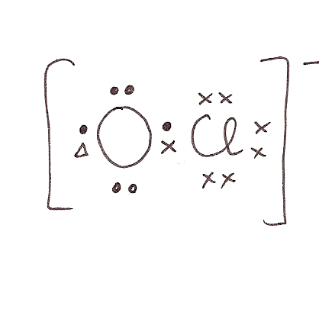 | BF₃  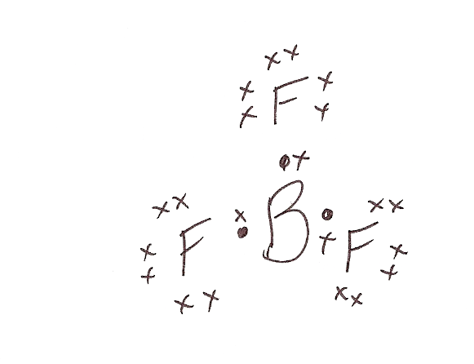
CS₂  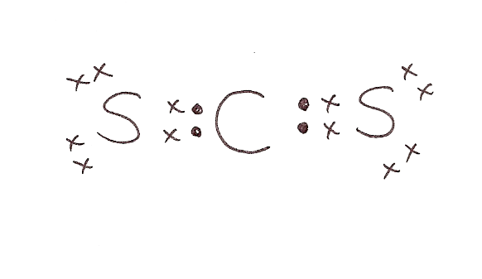 | NH₄NO₂  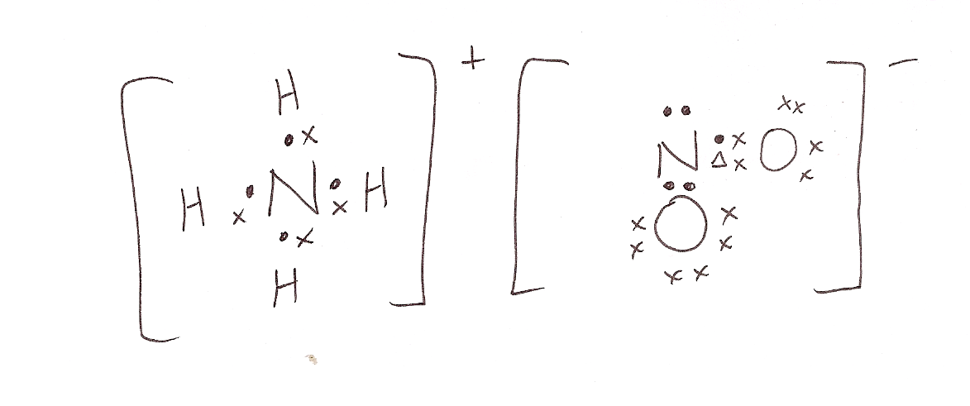

(4 marks)
3. Write down electron configuration (using s, p, d notation) for the following species
a) nitride ion 1s²2s²2p⁶

b) potassium atom 1s²2s²2p⁶3s²3p¹

4. A crystal of iodine, heated gently in a test-tube, gave off a purple vapour. A crystal of sodium iodide, heated to the same temperature remained unchanged.

a) Explain the above observations in terms of structure and bonding.

- Iodine is covalent molecular with only weak forces of attraction between its molecules (1mk)
- Sodium iodide is an ionic substance with strong forces of attraction between ions throughout the lattice (1mk)
- Sodium iodide needs more energy to separate its particles and allow a phase change to occur (1mk)
(3 marks)
b) Give the formula for the species responsible for the purple colour.

I₂(g) (1 mark)
5. Pure water undergoes self-ionisation according to the following equilibrium:

2H₂O(l) ↔ H₃O⁺(aq) + OH⁻(aq)

The equilibrium constant for the ionisation of water (K_{w}) is 1.0 x 10⁻¹⁴ at 25ºC

Write the equilibrium constant expression for this reaction.

K = [H₃O⁺][OH⁻]

As the temperature is decreased the value of K_{w} decreases.

Is pure water acidic, basic or neutral at 10ºC? Explain your answer.

Neutral (1mk)
The concentration of H⁺ ions is still equal to the concentration of OH⁻ even though the temp has changed and hence water is still neutral (1mk)
(2 marks)
6. Consider the 0.1 mol L⁻¹ solutions of:

Sodium hydroxide
Ammonium chloride
Sulfuric acid
Ethanoic(acetic) acid

a) Which solution would have the lowest electrical conductivity? Explain your answer.
Acetic acid is the only weak electrolyte (because it only partially ionises in solution) and hence it has the lowest electrical conductivity because it has the lowest total concentration of ions (3mk)
b) Which solution would have the highest pH? Explain your answer.

NaOH (1mk) the most basic substance has the highest pH and this is the only strong base on the list (1mk)
c) Which solution would have the highest total concentration of ions?

H₂SO₄ (1mk)
7. Consider the following chemical substances.

PCl₃, SiO₂, SiBr₄, F₂, CS₂, BeH₂, NH₄I, HCOOH

List all the non polar molecules | F₂ CS₂ BeH₂ SiBr₄
List the molecules which would have hydrogen bonds between them | HCOOH
List the pyramid-shaped  molecules | PCl₃
(6 marks)

8. Write equilibrium constants for the following chemical equilibria:

a) TiO₂(s) + 2 Cl₂(g) + 2 C(s) ↔ TiCl₄(g) + 2 CO(g)

b) [Fe(H₂O)₆]³⁺(aq) + 6 SCN⁻(aq) ↔ [Fe(CN)₆]³⁻(aq) + 6H₂O(l)
a)
K = [TiCl₄][CO]²
[Cl₂]
b)
K= [Fe(CN)₆ ³⁻]
[Fe(H₂O)₆ ³⁺][SCN⁻]⁶

(2 marks)
9. Calcium carbonate decomposes when heated

Energy + CaCO_{3(s)} ↔ CaO_{(s)} + CO_{2(g)}

If the mixture is present in a closed container equilibrium will be established.

Predict the effect of the following changes on the concentration of carbon dioxide at equilibrium and explain your predictions.

Change  Imposed | Effect on conc of CO_{2(g)} | Explanation
The pressure inside the container is increased by reducing the volume of the container | No change | Initially there is a sudden increase in[CO2] and then the reverse reaction is favoured to re-establish equilibrium and so [CO2] is restored to original level  Because in this case K=[CO2]
Helium gas is added | No change | Helium gas particles do not participate in reaction and so neither forward or reverse reaction rate is affected and equilibrium is undisturbed
A small quantity of CaCO_{3(s)} is added | No change | Amount of solid does not affect rate of forward or reverse reaction and so equilibrium is undisturbed
(9 marks)
10. Describe briefly a chemical test and observations by which you could distinguish between the following pairs of chemical substances. Equations are not necessary.

Substances | Test | Observations
Ba(NO3)2  and  Pb(NO3)2 | Add solution sodium hydroxide | The lead nitrate solution will form a white precipitate
Solid silver chloride  and  solid silver carbonate | Add hydrochloric acid to both | The silver carbonate will produces bubbles, the silver chloride will not

(4 marks)

11. Part of the Contact process for the manufacture of sulphuric acid involves the conversion of sulfur dioxide to sulfur trioxide as shown by the following equation
2SO₂(g) + O₂(g) ↔ 2SO₃(g) ∆H= -192kJmol⁻¹

In a study of this process, a container was filled with an equilibrium mixture of sulfur dioxide, sulfur trioxide and oxygen in the presence of a catalyst. The container was initially at 450ºC and was very well insulated.

An experiment was conducted on the container and the concentrations during the experiment are shown on the graph below:

a) What change was imposed on the system at the 10 minute point? (1 mark)

some oxygen gas was added to the mixture

b) Which components of the equilibrium mixture are represented by the lines labelled X and Y?

X SO₃

Y SO₂ (2 marks)

c) Give explanations for the changes in concentration that occur in X, Y and O₂ between 10 and 20 minutes

the increase in conc of O2 means increase in forward rate (1mk)
because of increase in collisions between O2 and SO2 (1mk)
this means conc of SO3 increases and O2 and SO2 decreases until equilibrium is re-established (1mk) (3 marks)
d) Would the temperature of the mixture increase, decrease or remain the same between 10 and 20 minutes? Explain your answer

increase (1mk)
the forward reaction is exothermic and it is the one favoured during this period of time (1mk)
system not likely to lose too much heat as it is well insulated (1mk) (3 marks)
Part Three Calculations
1. a) 3Ba²⁺(aq) + 2PO₄³⁻(aq) → Ba₃(PO₄)₂(s) (2mk) doesn’t have to be ionic

b) 3 BaCl₂ + 2Na₃PO₄ → 6NaCl + Ba₃(PO₄)₂
n=cv
=(0.145)(0.05) = 7.25 x 10⁻³ (1mk)

nBa₃(PO₄)₂ = ½ x Na₃PO₄ (1mk)
= ½ x 7.25 x 10⁻³
= 0.003625M (1mk)

massBa₃(PO₄)₂ = 0.003625 x ( 3 x 137.3 + 2x30.97 + 8x16)
= 0.003625 x 601.84 = 2.18g (1mk)

c) nNa⁺ = 3 x nNa₃PO₄ = 3 x 7.25 x 10⁻³ = 0.02175mol (1mk)

v_{T}= 100mL (1mk)

c = n/v = 0.02175/0.1 = 0.218M (1mk)

2. If 50mL of water is added to 25mL of 2M H₂SO₄ what will be the pH of the resulting solution? (4 marks)

nH₂SO₄ =cv = (2)(0.025) = 0.05mol (1mk)
v_{T} = 50 + 25 = 75mL = 0.075L (0.5mk)

cH₂SO₄ = n/v = 0.05/0.075 = 0.667M (1mk)

[H⁺] = 2 x 0.667 = 1.333M (1mk)

pH = -log [H+] = -log (1.33) = 0.125 (0.5mk)
3.
a) SiO₂ + 3C → SiC + 2CO (1mk)

b) 125600/28.09 + 2x16= 63500/21.01 =
125600/60.09= 5287.3mol (1mk)
2090.2 mol (1mk)

Need ratio SiO₂/C = 1/3 = 0.33/1

Given ratio SiO₂/C = 2090.2/5287.3 = 0.395/1

Therefore LR is C (1mk)

c) nSiC = 1/3 x nC = 1/3 x 5287.3 = 1762.4 (1mk)

mass SiC = 1762.4 x 40.1 = 70672g = 70.6kg (1mk)

d) nSiO₂ used = 1/3 x nC = 1762.4mol

moles SiO₂ leftover = 2090.2-1762.4 = 327.8mol (1mk)

mass SiO₂ leftover = 327.8 x 60.09 = 19.7 kg (1mk)

4. a) i) mass ZnSO₄ = 2.086g
nZnSO₄ = 2.086/65.38 + 32.06 + 4x16 = 2.086/161.44 = 0.01292mol (1mk)

ii) mass H₂O lost = 3.715 – 2.086 = 1.629g (1mk)

moles H₂O lost = 1.629/18.016 = 0.0904mol (1mk)

(iii)
 | ZnSO₄ | H₂O
moles | 0.01292 | 0.0904
ratio | 0.01292/0.01292=  1 | 0.0904/0.01292=  7

X = 7 (1mk)

b) i) Zn = 0.015g needed
nZn needed = 0.015/65.38 = 0.0002294mol (1mk)
nZnSO₄.7H₂O needed = 0.0002294mol (1mk)

mass ZnSO₄.7H₂O needed = 0.0002294 x (287.552) = 0.066g (1mk)

ii) c = n/v = 0.0002294/0.005 = 0.0459M (2mk)

5.
 | Rough | 1 | 2 | 3 | 4
Final Volume (mL) | 42.6 | 38.10 | 32.55 | 45.10 | 38.75
Initial Volume (mL) | 10.0 | 5.65 | 2.05 | 12.70 | 6.35
Titre (mL) | 32.6 | 32.45 | 30.5 | 32.4 | 32.4

a. i) average titre= 32.45 + 32.40 + 32.40/3 = 32.42 mL(or 32.40 mL using two values)
n(OH⁻) = cV = 0.121 x 0.03242 = 3.922 x 10⁻³ mol (3.920 x 10⁻³ mol)
n(H+) in 25.00 mL = 3.922 x 10⁻³ mol (3.920 x 10⁻³ mol)
c(HCl) = n/V = 0.1569 = 0.157 mol L-1 HCl

ii) n(HCl) = cV = 0.1569 x 4000 = 628 mol (627 mol)

b. i) Ca(OH)₂(s) + 2H⁺(aq) → Ca²⁺(aq) + 2H₂O(l)
ii) n(Ca(OH)₂) = n(limestone, CaCO₃) = ½ n (HCl) = 313.8 mol (313.6)
m(Ca(OH)₂) = nM = 313.8 x 100.009 = 31407.6 g
actual mass required 100/92.3 x 31407.4 = 34.03 kg

- a)
 | C | H | N | O
% | 68.15 | 6.87 | 0.177/1.112 x 100 =  15.9 (1mk) | 100 – 90.92 =  9.08 (1mk)
g/100g | 68.15 | 6.87 | 15.9 | 9.08
mole | 68.15/12.01 =  5.674 (0.5mk) | 6.87/1.008=  6.815 (0.5mk) | 15.9/14.01=  1.135 (0.5mk) | 9.08/16=  0.5675 (0.5mk)
ratio | 5.674/0.5675=  10 | 6.815/0.5675=  12 | 1.135/0.5675=  2 | 0.5675/0.5675=  1 (1mk)

EF is C₁₀ H₁₂N₂O

- EF mass is (10 x 12.01) + (12 x 1.008) + (2 x 14.01) + 16 = 176.2 (1mk)

PV = nRT
(106.3)(0.633) = n(8.315)(428)

n = 0.0189mol (1mk)

n= mass/molar mass
0.0189 = 3.33/molar mass

Molar mass = 176.2 (1mk)

Molar mass/EF mass = 1 therefore molecular formula is C₁₀H₁₂N₂O (1mk)

The following table contains information about the melting points and conductivities of some substances.

Compound | Melting point (ºC) | Electrical Conductivity in aqueous solution | Electrical Conductivity in the liquid state
Methylbutane  CH₃CH₂(CH₃)CH₂CH₃ | -160 | n/a | very low
silicon | 1410 | n/a | very low
cobalt | 1495 | n/a | very high
ethanoic acid  (CH₃COOH) | 17 | moderate | low
water | 0 | low | low
sulfur (S₈) | 113 | n/a | very low
lithium sulfide | 900 | high | high

Discuss the forces between the particles involved in solid samples of each of the substances, and so account for their melting points and conductivities.

Quick plan
